**Task:** Moving the jar file and csv file to /test_data from /home/hdfs and performing map-reduce procedure. Mapping (logic in jar file) is done on the input file (SalesJan2009.csv file) to give the output in /test_data/mp_output. The logic in jar file is to perform the total count of each category.

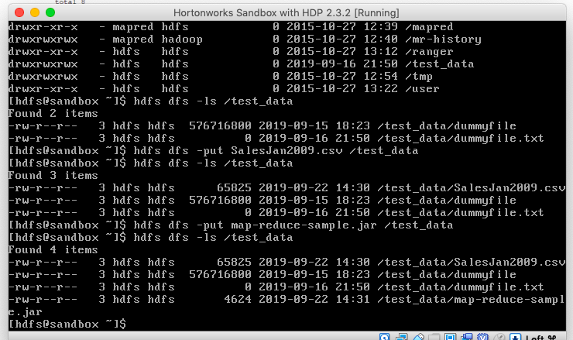

Moved the file from home to test_data under /.

Switched to Hortonworks Sandbox 2.6.5

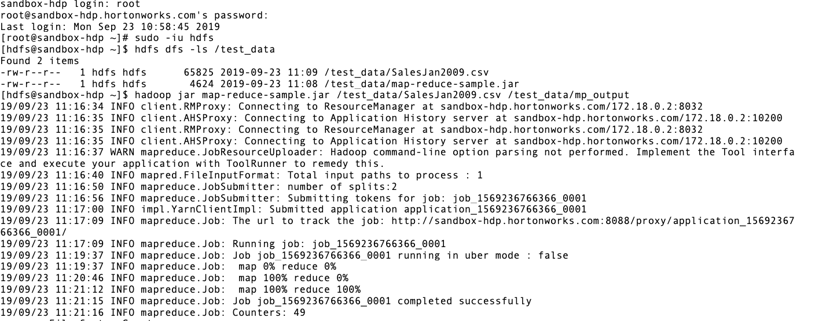

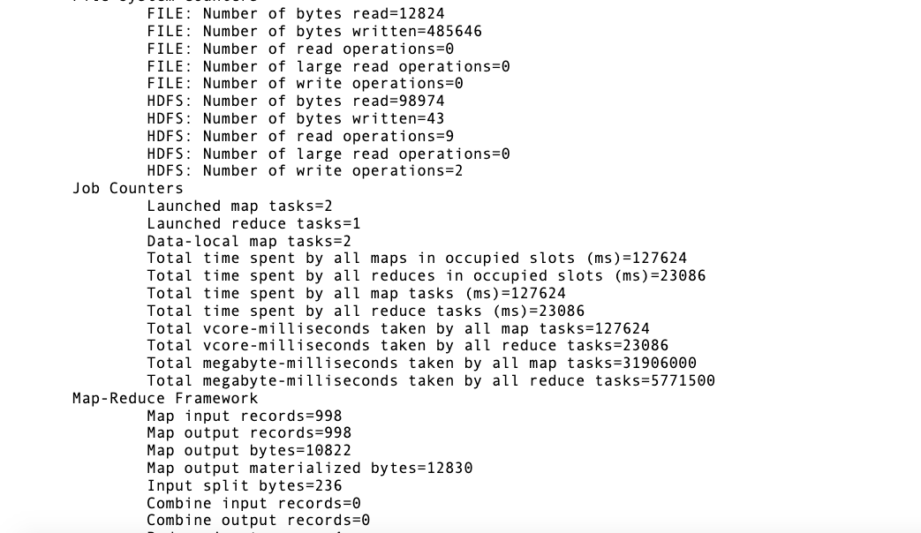**Command:** hadoop jar map-reduce-sample.jar /test_data/SalesJan2009.csv /test_data/mp_output

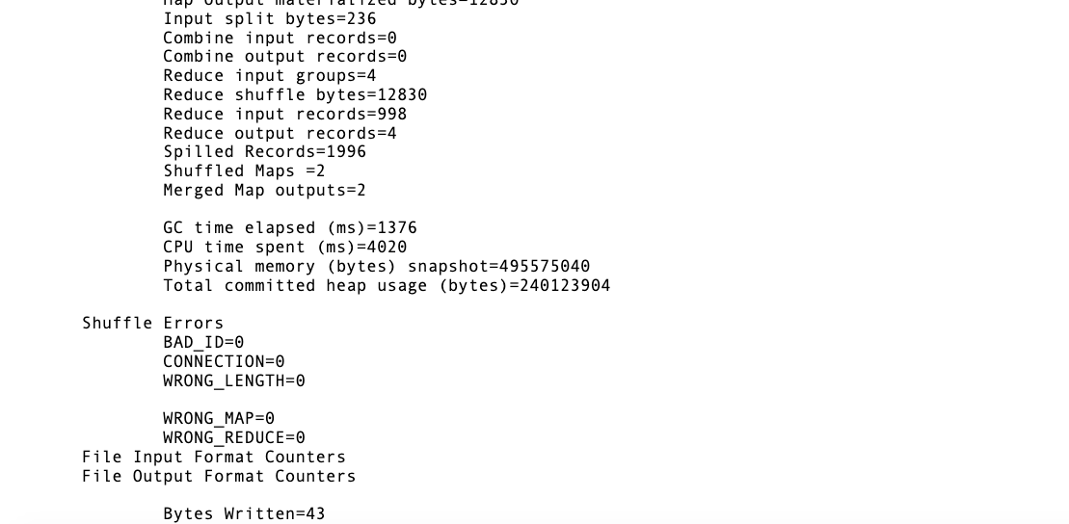**Output:**

